Mid Term Design Report for
PlayStation 3 Distributed Shared Immersive
Visualization Environment
Detection of Water Droplet Erosion

Sponsored By
IBM

Version 1.7
October, 12 2007

Prepared by
Syed Ali
Paul Ireifej
Justin Law
Carlos Lazo
Nicholas Matthews
Shahab Rastegar
Thomas Smith
Mahmutcan Tarzi

Executive Summary
The purpose of a steam turbine is to produce the maximum amount of electrical energy in the minimum amount of space. Steam is first heated in a boiler, where it reaches temperatures of approximately 1000ºF. It enters the turbine at a speed greater than 1,000 mph. A double-flow turbine design has steam entering in the middle and then traveling in both directions toward the ends of the section.
General Electric (GE), currently the largest manufacturer of steam turbines, is having issues with the erosion of their turbine blades within 2 – 3 years. The water droplets in the steam flow make contact with the turbine blades and the turbine captures the energy from the steam, but the condensing droplets erode the blades over time. Due to this erosion, mostly concentrated toward the blade tips, the energy that is captured decreases as the blades age.
The objective of this project is to develop a sensing system to measure the rate of metal erosion on the steam turbine blades. We need to prove to GE that they can use our diagnostic software to run an experiment on their turbine, each experiment taking approximately 4 – 6 months to set up, and 1 month to run.
The team is working in collaboration with the GE fall 2007 Erosion team. We are expecting images as input from this group. We will then run our image processing software to quantify the amount of erosion on the blade.
Our overall system design, represented as a flow chart in Figure 1, begins with the rotating turbine blades. The “simulation hardware” sub-system consists of the bore scope camera that is connected to a desktop computer. The “control PC” sub-system is attached to the “communication system” sub-system. This module acts as the connection from the PC to the Sony PlayStation 3 (PS3), which is the core hardware system for the project. After being taken by the bore scope camera, the images are transferred through the PC to the PS3 via the wired gigabit ethernet. To make the software development and testing easier, a network will be set up on the PS3 which will enable the team members to access the operating system remotely, in addition to a virtual network computing (VNC) type of repository to work on code simultaneously on an interface that can merge the code effectively.
The PS3 utilizes a cell processor, which performs complex calculations in real time. This cell processor can handle special graphical concepts, such as terrain mapping, image processing and signal processing algorithms. Hence, it is useful in determining the degree to which a turbine blade is eroded.
In order to use the PS3’s graphical capabilities effectively the team installed the Linux operating system. The team has chosen the Yellow Dog (YDL) distribution because Terra Soft Solutions, the designers of Yellow Dog, included all necessary drivers for the PlayStation 3 and the IBM SDK, as default in the installation. It includes stable, functional compilers for code development, such as the “LibSPE2” library. This library contains a threading model that will allow us to send C/C++ routines to get processed on individual Synergistic Processor Elements (SPE) in parallel.
Once the images are on the PS3 Linux O/S, they will be processed to determine the amount of erosion using various image processing techniques such as subtraction, average distance and edge size standard deviation. The performance of the algorithms will be determined and analyzed for possible optimization.
Currently, the team has the IBM SDK installed on the PS3. A simple “hello world” program has been successfully compiled and executed. In addition, remote SSH is operational: The dynamic domain name system (DDNS) allows the team to create a hostname that points to individual’s IP address or URL. The team is beginning to explore various image processing options in-depth. Furthermore, the decision has been finalized to use MATLAB as a test bed to model algorithm implementations as a preliminary step to coding.
In the end, the developed software will output numbers to a log file that will consist of quantitative measurements to determine erosion consistency. This will contribute significantly to GE’s research to understand the erosion process more thoroughly.

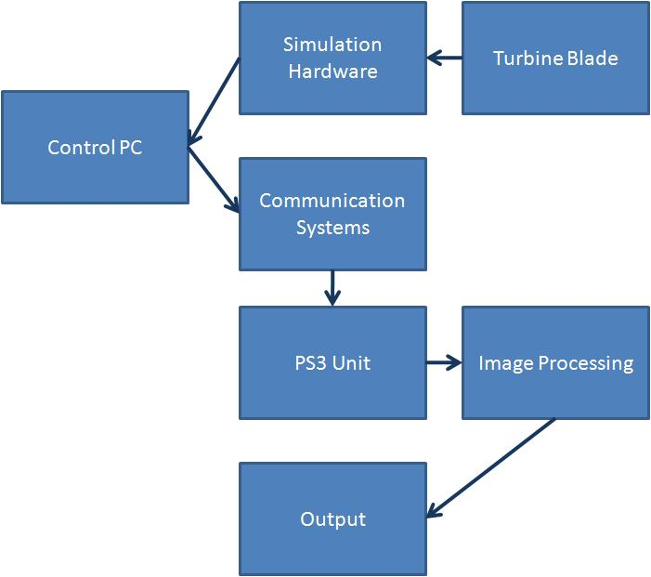
Figure 1 - Overall System Flow Chart

Table of Contents

Executive Summary 2
Table of Contents 5
Table of Figures 7
Table of Tables 8
Revision History 9
Terms and Abbreviations 10
1. Introduction 12
2. Customer Needs Analysis 13
3. Assessment of Relevant Existing Technologies 16
Sony PS3 & Development Environment 16
IBM’s Cell Processor 17
Operating System 18
Networking 18
Image Capture 19
Image Analysis Algorithm 20
Image Processing 20
MATLAB Image Processing 22
LibSPE 22
4. Semester Objectives 25
5. System Requirements 28
6. System Concepts and Analysis 30
7. Summary of Preliminary Engineering Analysis 39
8. System Specification, Preliminary Design, Status of Fabrication, and Status of Procurement 45
Simulation Hardware 46
Communication System 49
Image Processing 50
PS3Unit 52
9. Project Plan 54
10. Project Risks 60
11. References 63
Appendix A: Test Plan 67
Appendix B: LibSPE2 Sample Code 68

Table of Figures
Figure 1 - Overall System Flow Chart 4
Figure 2 - IBM’s Cell Broadband Engine Processor [Wikipedia 2007] 15
Figure 3 - Cell Broadband Engine Architecture [Valdes 2007] 16
Figure 4 - Process Flow Diagram of Image Capture System for spring 2007 Team [Bara 2007, Cabral 2007] 20
Figure 5 – Simulation Hardware 22
Figure 6 - Kollmorgen Servostar Controller 22
Figure 7 - PS3 Processors [Williams 2006] 36
Figure 8 - Overall System 44
Figure 9 - Preliminary Design for Simulation Hardware 46
Figure 10 - Flow Chart of Communication System 48
Figure 11 - Libspe Flow Chart 50
Figure 12 - Gantt Chart 56
Figure 13 - spe_hello.c 67
Figure 14 - spe_hello_toe.s 67
Figure 15 - Uses the SPE compiler to compile and link into an SPE executable file 67
Figure 16 - Create and run "pthread " 67
Figure 17 - SPE context 68

Table of Tables
Table 1 - IBM customer requirements 14
Table 2 - GE customer requirements 14
Table 3 - PS3 comparison to other processors [Williams 2006] 35
Table 4 - Preliminary Budget 56
Table 5 - Project risks 58

Revision History
Version | Date | Name | Reason for Changes
1.0 | 10/10/07 | Paul Ireifej | Initial edition
1.1 | 10/11/07 | Paul Ireifej | Updated Project Plan (section 9),  Added Appendix B: LibSPE2 code,  Added GE Final Report reference.
1.2 | 10/11/07 | Paul Ireifej | Updated Customer Analysis (section 2),  Added GE Mid-term Report reference,  Added Spring PSDSIVE Mid-term reference.
1.3 | 10/11/07 | Paul Ireifej | Added Communication Systems in section 8.
1.4 | 10/11/07 | Paul Ireifej | Added Appendix A: Test Plan
1.5 | 10/12/07 | Thomas Smith | General Housekeeping & Proofreading
1.6 | 10/12/07 | Mahmutcan Tarzi | Updated Customer Needs analysis  Minor corrections, centering of images
1.7 | 10/12/07 | Paul Ireifej | Change font for GE table,  Added Appendix A to ToC.

Terms and Abbreviations
BSD – Berkeley Software Distribution
C – General-purpose, block structured, procedural, imperative computer programming language developed in 1972 by Dennis Ritchie at the Bell Telephone Laboratories
C++ – General-purpose programming language with high-level and low-level capabilities.
CBE – Cell Broadband Engine
CBEA – Cell Broadband Engine Architecture
CBEP – Cell Broadband Engine Processor
CCD – Charge-Coupled Device
CESOF - CBE Embedded SPE Object Format
DDNS – Dynamic Domain Name System
DSIVE – Distributed Shared Immersive Visualization Environment
DVD – Digital Versatile Disc
ECSE – Electrical, Computer & Systems Engineering department at Rensselaer Polytechnic Institute
EIB – Element Interconnect Bus
FPS – Frames per second
FTS – File Transfer Protocol
GB – Gigabyte
GE – General Electric
GHz – Gigahertz
GPL – General Public License
GPU – Graphical Processing Unit
IBM – International Business Machines Corporation
IDE – Integrated Development Environment
IP – Internet Protocol address
JPEG – Joint Picture Experts Group
MATLAB – Matrix Laboratory; numerical computing environment and programming language
Matrox – Matrox Electronic Systems Ltd. (Matrox Imaging)
MDL – Multidisciplinary Design Laboratory at Rensselaer Polytechnic
MFG – Memory Flow Control
OpenGL ES – Open Graphics Library Embedded Systems
O/S – Operating System
PC – Personal Computer
PPE – Power Processing Element
PPU – Physics Processing Unit
PS3 – PlayStation 3 from Sony Entertainment
PSGL – PlayStation Graphics Library
RAM – Random-access memory
RPI – Rensselaer Polytechnic Institute
RPM – Rotations per Minute
RSX – Reality Synthesizer
SDK – Software Development Kit
SIMD - Single Instruction, Multiple Data
SSH – Secure Shell
SPE – Synergistic Processor Elements
SPU – Synergistic Processor Unit
STL – Standard Template Library
SVGA – Super Video Graphics Array
TATL – Trace Analysis Tool and Library
TIFF – Tagged Image File Format
URL – Uniform Resource Locator, network-retrievable document from the World Wide Web
VM – Virtual Machine
VNC – Virtual Network Computing
XL – eXtensble Language
YDL – Yellow Dog Linux

Introduction
Steam turbines are a quintessential part of our evolving technological world, providing a plethora of businesses and individual customers with many distinct energy solutions. The turbine itself contains several stages, each one containing varied sets of rotating and stationary blades, also known as buckets. Upon exiting the boiler (the repository for condensation), the steam is pushed through different turbine blade configurations, converting the potential energy of the steam into kinetic energy. The stationary blades aid in directing the flow of the steam, allowing for a maximum rotational speed and electrical yield. A pressure gradient is present within the turbines (high pressure in the front and low pressure in the back), further helping the velocity of the steam. Acting as a heat-force engine, the turbine truly harnesses the power of thermal energy. The mechanical energy generated in the turbine shaft grants us the ability to generate the electricity we all use in our daily lives [Wikipedia, 2007].
General Electric has been a cutting edge researcher in the field of steam turbine technology for quite some time. They have come to RPI with a very realistic problem which many turbines are facing – water droplet erosion. With many turbines spinning in excess of 3000 rotations per minute (RPM), the steam condenses and forms water droplets which hit the ends of the buckets at extremely high velocities. Over time, these collisions begin to erode the blades, causing a decrease in performance and a need for repair. Although research has been conducted to determine certain external factors that cause the erosion (such as steam composition and temperature), General Electric would like a real-time image capture system developed to see at what speed the erosion is occurring. At the same time, IBM is interested in exploring the diverse possibilities of the PS3 processor.
Utilizing the PS3 and its computing capabilities as the crux of our project, the team is looking to develop and improve the functionality of a real-time image capture system for steam turbine erosion detection. A Matrox imaging program written by the spring 2007 IBM team will be used as a stepping-stone for our code development. All initial algorithmic processes will be written and fully tested in the MATLAB environment. Once a sufficient level of accuracy and precision is attained, the code will be converted into the C language and migration to the SDK on the PS3 will be performed. Full optimization using the Cell processor will be dependent upon proper implementation of our image processing technique.

Customer Needs Analysis
The main sponsor of this project is IBM. Further benefit should occur, if there is any professionally viable and feasible solution found, to GE and the whole electric generation industry, as our project’s aim is to develop an efficient image sensing tool which could and would be used to gain higher efficiency and higher life expectancy of the steam turbine blade. Measures against erosion may then be implemented much faster and more would be known about water droplet erosion.

Directly Influenced:
- The project sponsor, IBM
- General Electric
- Future development groups in DSIVE or ECSE Design

Indirectly Influenced:
- Commercial entities with possible CBE applications
- Academic/scientific entities utilizing CBE

For IBM the main expectation is, for us to be fully utilizing the power of the Cell Broadband Engine (CBE) in a useful manner, therefore demonstrating it’s capabilities in solving a computationally intensive real life problem. It is needed to demonstrate the extensive computational capabilities of the CBE and it’s prowess in floating point kernels. Parallel processing and vector processors will be utilized in a computationally challenging area, optical detection.

For GE, it is necessary to develop an effective and efficient sensing mechanism to measure the rate of metal erosion on steam turbines. It is desired to have a modular unit that can interface with the turbines using existing mechanical portals, such as the borescope hole. It is also desired to automate the task of measuring, quantifying and notifying.

To give an idea on how computationally intensive an immersive visualization environment (IVE) is, the X-Rooms environment, a PC based IVE located in Technical University Berlin, uses 13 PCs ( 950 Mhz Pentium III, 256 MB, GeForce 3 with 64 MB and 100 Mbit Ethernet). This is not an optical sensing environment, but rather a display environment, which could also benefit from the power of the CBE.

Measurable objectives for the project will mostly be software based, including:

- Research and installation of a non-native OS that is able to best utilize the CBE (performance of the OS, boot-time, memory efficiency)
- Network connectivity (speed of image transfers)
- Implementation of image optimization (speed and quality of image analysis)
- Implementation of image difference sensing algorithms (speed and quality of image analysis)
- Parallel processing and logging of all the data in an efficient manner (speed of algorithms)
Table 1 and 2 below summarizes the customer requirements and give a rating relative to their importance, with respect to the company.

Table 1 - IBM customer requirements
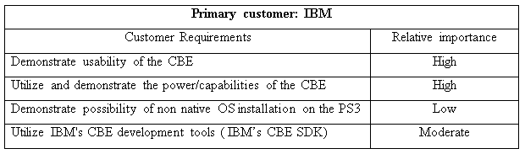

Table 2 - GE customer requirements
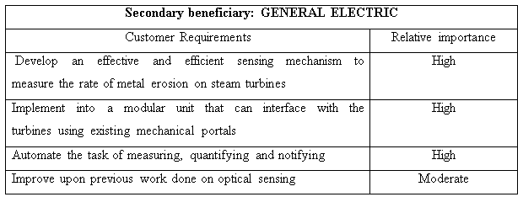

Assessment of Relevant Existing Technologies

Sony PS3 & Development Environment

The Sony PlayStation 3 (PS3) is efficient in image processing because its cell processor is capable of performing complex calculations in real time. The PS3 uses parallel processing and Cell Broadband Engine Architecture (CBEA), which has the ability to manage real-time data quickly [Helpero 2007]. From the hardware perspective, the PS3 cell processor contains 9 elements: 8 Synergistic Processor Elements (SPEs) and 1 Power Processor Element (PPE). The graphics component of the PS3 is contained in the SPEs. Linux can install onto the PPE. A diagram of this is shown in Figure 2.

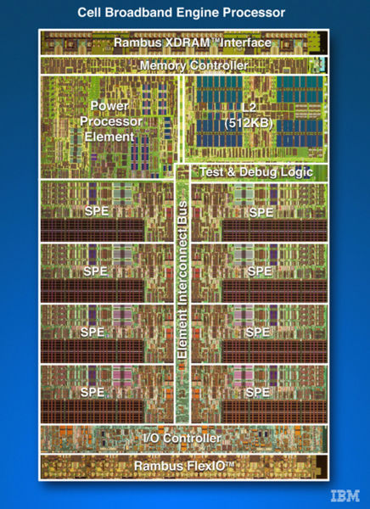
Figure 2 - IBM’s Cell Broadband Engine Processor [Wikipedia 2007]

IBM’s “LibSPE” is the standard library that PPE programs use to access and manage SPEs. IBM’s CBE SDK is a complete CBE development environment that includes the IBM library and samples source code, IBM XL C/C++ Alpha Edition for CBE Processor, IBM Full-System Simulator for the CBE Processor, and an Eclipse-based Integrated Development Environment (IBM Cell Broadband Engine Software Development Kit 2005).
Terra Soft’s Yellow Dog Linux 5.0 distribution contains various developer tools. Also, it is the most complete thoroughly tested, professional Linux distribution for the Power architecture. However, because of its lack of maturity, the developer community is relatively small compared to more popular distribution alternatives [Paul 2007].
IBM’s SDK will be important for developing software to process the images of the turbine blades with erosion effects. The “LibSPE2” library was recently developed to allow for functional indirect use of the PS3’s GPU. For software development, Vim seems to work the best as an IDE. Being that we are going to communicate with drivers, C/C++ is the direction we would be heading to accomplish the low-level tasks.

IBM’s Cell Processor

The cell processor is a non-homogenous coherent multiprocessor that is designed to work at high design frequencies and a low operating voltage with advanced power management. It also features a homogenous multi-core architectural system, better known as a Power Processor Element, for control tasks and Synergistic Processor Elements for intensive data processing [Valdes 2007].
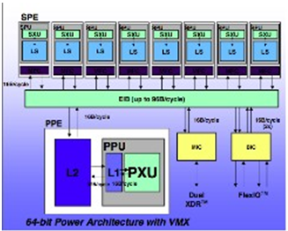
Figure 3 - Cell Broadband Engine Architecture [Valdes 2007]

In Figure 3, the Synergistic Processor Element (SPE) consists of 8 Synergistic Processor Units (SPU) and a Synergistic Memory Flow Control (MFC). Essentially, we are looking at 8 cores processing data simultaneously while synchronized by the MFC and the Element Interconnect Bus (EIB) [Amarasingehe 2007]. These SPUs are vector processors designed to simultaneously process a clusters of data at a high speed [Valdes 2007].
In order for the image capture data to be useful, it should be formatted into a suitable configuration so that the user can carry out proper analysis. Teams from previous semesters have been using JPEGs and converting them to gray-scale Bitmaps, which allow for image processing code to process raw image data.
It is necessary for the image format to be a lossless file type with a simple structure. Although the previous team has stated that the bitmap format made most sense for the project, our group will explore other possibilities.

Operating System

In using the PS3 Cell Broadband Engine chip, a compatible Operating System will have to be utilized. The PS3 has a PowerPC processor. Operating systems working only on x86 or x86-64 processors will not run on PS3’s cell [PS3 Linux FAQ Thread 2006]. Therefore, only viable and sufficiently reliable options were considered and reviewed here. Among the candidates were various Free Linux distributions and FreeBSD, which is an advanced UNIX based O/S [Hertzfeld 2007].
As a conclusion of the research done on different operating systems, Yellow Dog Linux will be used because it is referenced as “the best ready package you can get, with some of IBM's Cell development tools preinstalled” for the Cell Broadband Engine [Yellow Dog 2007, AfterDawn.com 2007].

Networking

The PS3 will be receiving image data through the network port on-board. The network port is a Gigabit Ethernet, or 1000 Mb per second. The PS3 will be able to receive images from a network camera or a PC transferring data from a connected computer. For simplicity’s sake, a network camera is preferred for the project. A large majority of the cameras use FTP to transfer the images, which will make acquiring the images on the PS3 quite simple.
To compute the bandwidth that the team will be working with, the Axis 206 network camera specifications were used. The camera sends a 640 x 480-pixel image 30 times a second [CDW Corporation 2007]. The picture is sent in JPEG, which converts to approximately 10:1 to 20:1 compression [Lane 2007]. This means that the bandwidth the camera outputs is about 10-20 Mbs, which the Gigabit interface will be able to handle with ease.
In order to enable the team to work on the project from outside the MDL, there will be a suite of remote access protocols installed onto the PS3. The team will be using SSH, VNC, and Samba. The team may need to find a work around VNC only supporting one user at a time, with a sort of VNC manager [Files Library 2005].

Image Capture

The camera the team has used is a Toshiba IK-53V, a small CCD camera with an approximate SVGA resolution, frame rates of 60 and 180 FPS at full and quarter resolution respectively, and shutter speeds as quick as 1/100,00 seconds. The fast shutter will limit blurring when photographing operating turbines, and the high frame rate at full resolution will ensure that, even if stationary, the camera will capture images of the moving blade. There is potential room for cost-cutting here, as the IK-53V is a professional device and this project does not require its full potential. Much the same results could be had with a less expensive, high-end network camera.
The software side of the team’s solution will receive JPEG data from the camera and convert it into a more readily usable format in RAM. The decoding of the compressed data into a bitmap and the subsequent perspective correction for the bore scope’s fisheye lens will occur in one step to conserve time and memory, and a simple high-pass filter will be enough to check each bitmap for acceptable image clarity. Depending on the program architecture the team decides on and our ability to use make the most of the PS3’s six available SPUs, useful image data will either be stored for analysis at the cost of immediate quantitative output or shifted between SPUs for quick processing at the potential cost of dropped input frames.

Image Analysis Algorithm

To effectively analyze the pictures taken by the camera, the images must first be fixed and prepared. Clarity, detail and sharpness of the images are all criteria to be considered before final analysis can be made. Three image analysis methods have been implemented in the past and each method has advantages and disadvantages.
The first method is subtraction: in this method, a subtraction function is used to subtract a base image from a second image to be processed. The advantages with this method are that it is relatively simple to implement and requires the least amount of processing power. However, this method is highly dependent on lighting and the alignment of the images, as the images need to be perfectly aligned. It can be assumed that the turbine blades will be moving slow enough to capture steady images.
The second method is average distance: this method detects the longest straight line in the image and then calculates the average distance from the edge of the blade to a reference line. This method, unlike the subtraction method, does not require perfect alignment. Instead, it will simply shift the image, with respect to the position and tilt of the image. Although consistency of the light is not as important the amount of light, there needs to be sufficient lighting on the edge of the blade and on the scribed line for this method to work properly.
The third method is edge size standard deviation: this method verifies that the edge sizes have greater variance in more eroded buckets. This method is more robust and accurate compared with the other two suggested methods. However, the total number of steps needed to implement this method is greater than the other two methods.
After reviewing these methods, it was concluded that experimentation and testing will be the best way of deciding which image analysis approach is more effective and robust.

Image Processing

The commercial implementation of the IBM Cell Broadband Engine (CBEA) on the PlayStation 3 allows for extensive research to be done in the area of various algorithm possibilities at a relatively low cost. With a focus on image analysis and processing, previous teams used the many distinct elements of the PlayStation 3 to begin implementing simple imaging algorithms on the Fedora Core system. JPEG decompression into the BMP format was done using a free program called “djpeg” from the Independent Group (available at http://www.ijg.org). The decompression was done on the Synergistic Processor Units (SPU’s). Perl scripts were used to open JPEG images in specific directories automatically, split them into two distinct files, and then send them to two separate SPU’s. After the images were processed and a difference was determined, the information was stored locally on the PlayStation 3. A depiction of the image processing can be seen in Figure 4.

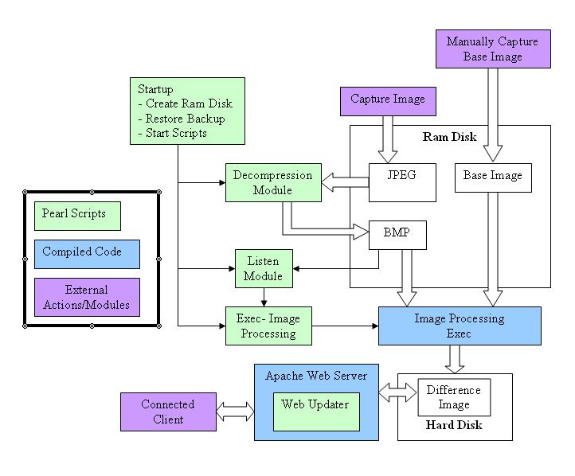
Figure 4 - Process Flow Diagram of Image Capture System for spring 2007 Team [Bara 2007, Cabral 2007]
As it stands, C programming is the main language that we can expect to utilize. The difference algorithms that were created seemed to have worked within reasonable time; more research needs to be completed on algorithm optimization. We are looking at possibly using the djpeg program & C routines or Image Magick, both compatible with the Yellow Dog OS [Bara 2007, Cabral 2007]. They both provide us with potential imaging solutions that may help us in refining images and fully establishing accurate comparisons.

MATLAB Image Processing

The team has made the decision of using rapid prototyping software in order to accelerate development and implementation of image processing algorithms. MATLAB was chosen as the prototyping software to be used in this project. There are many advantages to using MATLAB: The first advantage is the large amount of support provided by the user community and forums. Another advantage is that all group members have the license and know how to use it. More importantly, MATLAB includes an image processing toolbox that contains many of the needed functions for this project. Finally, MATLAB has the “Deploy Tool,” which can produce stand-alone code that can run independently of MATLAB. This will allow us to implement our algorithms and use the SDK to optimize out code for the cell processor.
However, there are a few disadvantages with using MATLAB: First, the license for the software is expensive. Second, the code that is deployed is not optimized and can be very computationally expensive. After much consideration, MATLAB was as our rapid prototyping software because the advantages greatly outweigh the disadvantages.

LibSPE

LibSPE is “the standard library that Power Processor Element (PPE) programs use to access and manage Synergistic Processor Elements (SPEs) [Bartlett 2007].” This library will be used to optimize the image processing, and sets the PS3 system apart from all other PC systems because of the Cells parallel processing capability.
LibSPE provides an interface for programmers to manage and communicate with SPE processes. It does not, however, modify the hardware resources. It is user-level code that requests SPE resources from the operating system. You can run one or more SPE simultaneous execution threads by creating that many threads in the PPE code and then run the SPE program in each thread. To do this, you must first create the SPE program, which is embedded SPE code. To run the SPE embedded code, a “phtread” must first get created and run (“pthread_create” command). Next, an SPE context must be created (“spe_context_create” command). Furthermore, the SPE code must be loaded into the SPE context (“spe_program_load” command). Finally, the SPE code can run until completion (“spe_context_run”)
Simulation Hardware
Currently, the simulation hardware consists of three main units, as shown in Figure 4. The first part consists of the housing for the mock turbine (this includes the blades and the motor). The second part consists of how the camera is mounted on the mock turbine, and how the lighting is setup. The last part consists of the electronics and control system for the motor and the image capture (either via a strobe light and camera of another method).

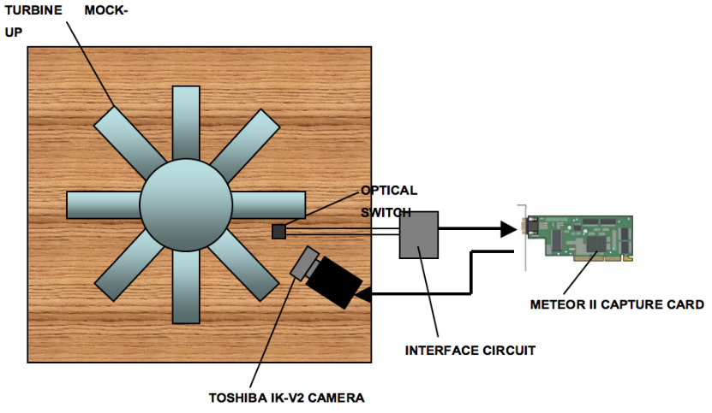
Figure 5 – Simulation Hardware
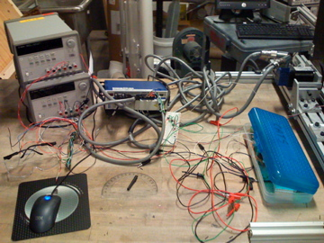
Figure 6 - Kollmorgen Servostar Controller
Figure 5 depicts the solution that was implemented last semester, which used a Kollmorgen Servostar Controller (MODEL NO. CR06250-000000 VERSION 3PH SERIAL NO. 00C-1099), some belt gears, potentiometers, resistors, a power supply, messy wires and an optical switch to control the simulation hardware. Although these components are capable of a great deal, they were implemented in a very sloppy fashion that could have lead to personal injury when operating the system.
The team is looking into using Labview (using a simple I/O board or a DAQ card) to create a control system for the motor. This would provide a robust and safe way to test the other components of the project. For example, Labview can be used to monitor the motor’s speed and send signals to trigger the camera. Additionally, the lighting system can be interfaced with Labview to provide a high degree of flexibility.
Another method for controlling the simulation hardware would be to use an Arduino Microprocessor. The advantages of using an Arduino Microprocessor include: it is small and very robust, there are many input and output ports that are programmable and implementing would be relatively easy in comparison to a Labview System. Figure 6 shows a picture of the Arduino Microprocessor [Arduino 2007].

Semester Objectives
The objectives that the team would like to fulfill involve integrating and expanding the work of previous groups. Working in conjunction with the fall 2007 GE Erosion team, we wish to create a working system that satisfies the expectations of RPI, GE, and IBM.
The objectives that the team wishes to achieve are largely image processing based issues, especially those involving developing systems for the PS3. A quality digital image, provided to us from the bore scope, is taken from the network and sent onto the PS3 hard drive. From here, the image is distributed to and analyzed on multiple SPE processors. Finally, the output is sent to a log file for viewing.
The following objectives have been evaluated according to the SMART principle: They are specific in that each objective has a precise outcome that is quantifiable, measureable in that the progress of each objective can be continually checked, achievable in that each objective can be completed within the remainder of the semester, relevant in that each objective will make a significant impact in the end result, and time-bound in that there is a clearly defined start and end date.

Install Yellow Dog Linux on PS3
- Objective: Install an operating system on the PS3
- In Scope: Installing IBM SDKs for development
- Out of Scope: Modifying the kernel for personal customization

Establish Network Connectivity and Access
- Objective: Make the PS3 accessible from the network
- In Scope: Configuring a static IP address for the PS3
- In Scope: Setting up VNC, SSH, and Samba for remote access
- In Scope: Establish connectivity to the PC or network camera
- Out of Scope: Managing network resources between the camera and PS3

Build Simulation Hardware
- Objective: Construct image simulation hardware to capture turbine blades.
- In Scope: Take a snapshot on one turbine blade per revolution
- Out of Scope: Build with the flexibility to process turbines of any given material

Transferring Image to the PPE for processing
- Objective: Transfer the data from the network interface to the PS3 processor
- In Scope: Move the data from the FTP stream to the PPE
- In Scope: Converting the image to a bitmap format for analysis
- Out of Scope: Transferring the image data directly from the network through sockets

Develop Parallel Processing Usage
- Objective: Utilize the parallel computing power of the CBEA
- In Scope: Using scripts to send data to multiple processors
- In Scope: Install software that optimizes code for multiple processors
- Out of Scope: Developing an architecture that converts code into a parallel computing system

Implement Image Optimization
- Objective: Optimize bitmap images so that they may be better analyzed
- In Scope: Implementing sharpening algorithms
- In Scope: Implementing rotating and sizing algorithms
- Out of Scope: Developing algorithms for optimization
- Out of Scope: Implementing complex image processing algorithm conversions

Implement Image Differentiation
- Objective: Compare two or more images analytically
- In Scope: Implementing multiple comparison algorithms
- In Scope: Creating a scale for determining the amount of difference
- Out of Scope: Developing new differentiation techniques
- Out of Scope: Creating custom digital imaging processing software for the PS3

Output Results to PS3
- Objective: Send the results of the differentiation to an output log
- In Scope: Establishing a directory and output system for results
- In Scope: Sending the results to a simple data log output
- In Scope: Transferring the output to a system log on the network
- Out of Scope: Developing a GUI for output

System Requirements
The Cell Broadband Engine (CBE) in the PlayStation 3 (PS3) is clocked at 3.2 GHz and is experimentally capable of 204 GFLOPS (billion floating point operations per second, single-precision). The PS3 specifically has 256MB DRAM central, plus an additional 256KB SRAM and a cache of 128 128-byte vector units per SPE [Wikipedia 2007].
The images acquired via the camera and bore scope are ballpark SVGA (649x494 exactly), but the useful data does not fill the whole frame. The bore scope gives a circular image surrounded by near-black; this circle is approximately 400 pixels in diameter. The exact size and position of this circular area is not set in stone, but is consistent from image to image in a set (i.e., the area to be cropped needs to be calculated only once per session).
The TIF example images we have are 8-bit grayscale, which is convenient in that the SPEs can handle as many as 8 16-bit numbers at once. It is not optimal, but the desired change (compatibility with 16 8-bit numbers in a 128-bit vector) is not implemented in hardware and would be nontrivial to simulate. Based on the number of pixels in the actual data-rich section of the image and the number of 8-bit raster pixels we can fit in a vector, linear functions (e.g., energy sum, difference, translation) will take approximately 22,000 SPE cycles. Using one SPE, this translates to seven thousandths of a second per linear operation, or 147 linear operations per second per SPE.
The following are included in this set of rapid instructions: loading an image from RAM to vectorspace, finding the total brightness of an image, cropping the dark parts of an image, finding the difference between two images, rotation by an arbitrary angle, etc. Further performance may be strained from the system by using lower-res images for rough operations. For example, coarse orientation alignment can be performed on images as small as 1/16th normal size (400x400 down sampled to 100x100), and the recursively determined results can be mapped to the full-resolution picture for further refinement of registration.
Since these operations are O(n), they will be sped up by a factor of 16 minus any overhead; we can expect over 2000 low-resolution translations, rotations, or comparisons per second per SPE. This figure may be inflated somewhat, as loading of RAM into cache is not free. Worst-case, the figure is 200% actual performance, and each vector to be used must be loaded from RAM seven scalars at a time [Future Gamez 2006].

Additional optimization is possible, though subtle and more complex. Using bitwise operations such as AND or XOR, a one-bit-per-pixel, purely black-and-white image could be processed at 128 pixels per SPE cycle. This works very well for energy functions, but not at all for rotations, and only sparingly for translations. Additionally, the trial-and-error process required to reach a suitable black and white image may be too time-consuming to justify even the rapid pace with which they could be used. At 128 pixels per clock tick, loading and comparing two one-bit-per-pixel images would take less than 5000 cycles – in other words, 640 such comparisons per second as a conservative estimate. Again, the additional calculation preceding and following these operations is not worth the extra effort.
This is, without consideration, more appropriate for complicated operations performed by MATLAB. Histogram stretching is not a preventatively complex algorithm to implement, but given the limited timeline on which the team is operating, MATLAB-deployed code or executables will be used to aid development. Matlab code exported into C or C++ can be compiled on the PS3, but is designed to be efficient and exact on scalar processors. We can expect to match performance between each SPE and a common PC, but the code will not initially take any advantage of the Cell’s unique features. Through optimization, we can expect clear improvements over PC performance, as Matlab (whose name is a contraction of “matrix laboratory”) is matrix-centric and the vector-based SPEs are well suited to its normal uses.

System Concepts and Analysis
The team is in the process of analyzing several concepts that will help to achieve the set semester objectives. Due to the time constraint, it is not possible to conduct experiments and prototype all possible solutions. Therefore, it is crucial for the team to find the best way to proceed by eliminating some choices using preliminary analysis and critical thinking.
Finding a way of processing and analyzing images plays a key role in the success of this project. The team has devised a list of criteria to narrow down its choices in this matter. One such criterion is accuracy, meaning a low amount of false results. A 5% margin of error has been set. Second, the algorithm used must be easy to develop so that it can be developed in a short amount of time. Third, the team must consider ease of implementation in that the number steps required to get output must be minimal in order to be able to easily automate the entire process. Finally, the amount of processing power must be considered: if the algorithm is computationally intensive, it will take a long time to calculate the output and the effort to optimize the code may be wasted. With the above-mentioned criteria in mind, the group must choose an appropriate algorithm.

Image Processing Algorithms under Consideration

Subtraction and Image Differencing
Description: In this method, a subtraction function is used to subtract a base image from a second image to be processed. The grayscale of both images are converted into matrices, and then the matrices are subtracted from each other. After aligning and reconstructing the image that needs to be processed, it will subtract the value of each pixel and sum the values of the entire image, which will be in matrix form. After calibrating with different eroded blades, the summed values will represent the degree of erosion.
Advantages:
- The method itself is relatively simple to develop and requires the least amount of research
- Requires relatively minimal amount of processing power compared to other methods
Disadvantages:
- Requires constant lighting
- Both images being compared must show the blade in identical conditions and orientation on the photo. The team is unable to produce images with that level of constancy so the image must be rotated and aligned: a process that is very computationally expensive.
- This method must be recalibrated for different turbines since a slight change in lighting will greatly decrease its accuracy.

Average Distance
Description: This method detects the longest straight line in the image. Then it calculates the average distance from the edge of the blade to a reference line.
Advantages:
- Does not require perfectly aligned images.
- Requires relatively low amount of processing power compared to other methods.
Disadvantages:
- It was implemented on Matrox
- Although consistent lighting is not required, the amount of light that is necessary is very high. There needs to be sufficient lighting on the edge of the blade, and on the scribed line.
- The positioning of the light is an issue because the light is positioned from behind the blade and towards the camera.
- The automatic placement of the scribed line may an issue.

Edge Size Standard Deviation
Description: This method finds all edges in the image and assumes their length to be a random variable. The standard deviation of this random variable is then calculated and mapped to the respective erosion level. The theory is that most eroded blades have, on average, longer edge length.
Advantages:
- It is more robust and accurate compared with the above methods
- Does not require perfect alignment of the images
- The images require very little preparation
- Less prone to error
Disadvantages:
- Although consistent lighting is not required, the amount of light necessary is very high. There needs to be sufficient lighting on the edge of the blade and on the scribed line.
- The positioning of the light is also an issue since the light is positioned from behind the blade and towards the camera.
- This was implemented using Matrox specific function, but must be developed for MATLAB.
- This may not be autonomous
- Needs more computational power compared to the other methods.
- Consistent lighting is needed so that same edges are seen and detected by the software.

Contour Edge Detection
Description: The tip edge of the blade is found using contour curve level setting iteration. Then the area between the edge and a scribed reference line is formed. The area is then mapped to its corresponding erosion level.
Advantages:
- It may be the most accurate method compare to the other methods being considered
- It requires very little preparation of the image before analysis
- Can be implemented in MATLAB
- Does not require perfect alignment or lighting
- Further analysis is possible using a second iteration, which projects the rate of erosion in the future.
Disadvantages:
- This has never been implemented or developed for our project and therefore, development time may be longer.
- It is very computationally expensive
- The scribed line placement may prove to be difficult to implement and automate

Output Consideration

Visual
Description: After the analysis of the image is complete, the system returns the image and shows all changes detected.
Advantages:
- Allows the operator to see if the software is accurate and if the results are valid.

Disadvantages:
- Development of this system may take too long and may be out of the scope of project.
- May take an extensive amount of system resources in terms of RAM and hard drive space.
Text log file
Description: The results are saved in text format: it specifies current and past levels of erosion.
Advantages:
- Very easy to develop compared to the visual method
- Takes a small amount of system resources to display results
Disadvantages:
- The operator has no way of knowing if the results are accurate or if an anomaly has occurred

The main professional and societal considerations in this project surround the use of the PS3’s cell processor to solve computational intensive problems, such as erosion detection on wind turbine blades due to steam condensation in the turbine. This is discussed with the following issues:

How this overall system will help GE improve its turbine maintenance and increase their turbines’ efficiency

The overall system that is being developed is composed of a PS3 console, interfaced with a high speed bore scope camera that is connected into a GE wind turbine. The system will help GE maintain their wind turbines and make sure that the amount of erosion on the blade does not exceed a certain limit. GE is responsible for determining when the turbine blades should be replaced. This replacement is crucial because damaged blades may permanently destroy the turbine blade. It is very important that GE knows the amount of erosion on the turbine blades so that they can replace the blades in a cost effective manner.
For example, if company A buys two turbines from GE: One running at 75% and the other running at 25% efficiency, then the turbine that is running at 75% could be replaced while the other turbine is running at 100% to make up for the lost energy during replacement. Thus, company A would not lose money nor end up with a broken turbine.
The only way that this method would be cost effective is if GE knows the exact date that the turbine blades would have to be replaced or have maintenance performed on them. The system that is currently being developed would help GE keep track of when maintenance is needed. Additionally, the cost of the system (PS3 Unit + bore scope camera) would be trivial compared to the cost of a replacement turbine.
Thus, the system has the potential to be integrated into every turbine produced. GE could generate energy statistics from their turbines, while keeping track of their condition. This system would be similar to the remote “OnStar” system currently being used in motor vehicles that help General Motors (GM) keep track of when their cars require maintenance and repair. In the end, both parties would benefit greatly from the diagnostic system being developed.

PS3’s energy efficiency and processor performance versus a PC with similar specifications

Another concern that one might have is whether the PS3 is appropriate for use in this system. What makes the PS3 the right computing platform for this project? Why not select a PC with similar hardware specifications?
According to a recent research paper that studied the use of the cell processor for scientific computing, by Lawrence Berkeley National Laboratory, the PS3 cell architecture demonstrates a tremendous amount of potential for scientific computation in terms of raw performance and power efficiency [Williams 2006]. The research paper also includes a comparison of the PS3’s cell processor to that of other processors, as shown in Table 3
.
Table 3 - PS3 comparison to other processors [Williams 2006]
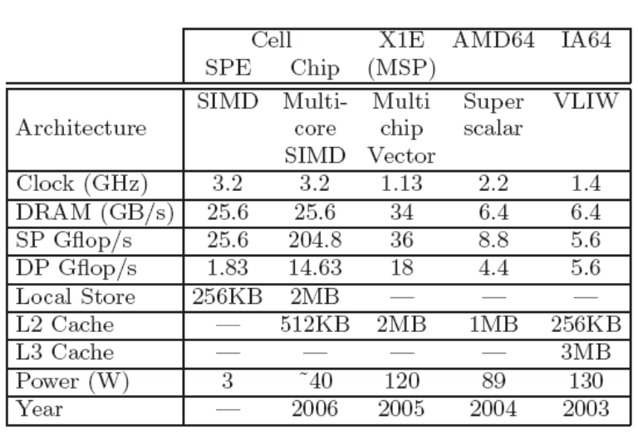

Table 3 shows that the cell processor has a faster clock speed as compared to the other processors. In addition, the amount of single precision flops per second is 5.68 times the competitor’s best performance. However its performance with double precision flops is comparable to other processors. Nonetheless, the cell processor demonstrates incredible performance for the cost of the unit when compared to the competition.
Moreover, the cell processor “is a high performance implementation of software-controlled memory hierarchy in conjunction with the considerable floating point resources that are required for demanding numerical algorithms. Cell takes a radical departure from conventional multiprocessor or multi-core architectures. Instead of using identical cooperating commodity processors, it uses a conventional high performance PowerPC core that controls eight simple SIMD (single instruction, multiple data) cores, called synergistic processing elements (SPEs), where each SPE contains a synergistic processing unit (SPU), a local memory, and a memory flow controller.” [Williams 2006] The 8 cores are responsible for this overwhelming performance because they emulate 8 separate processors working in parallel, as shown in Figure 7.

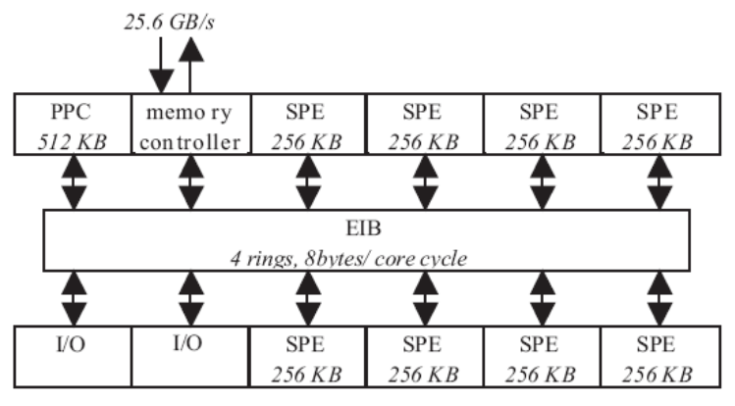
Figure 7 - PS3 Processors [Williams 2006]
Therefore, it is evident that the PS3 is the appropriate computing platform for this system. The PS3 is a cost effective solution to the complex computational problems. “On average, Cell is eight times faster and at least eight times more power efficient than current Opteron and Itanium processors, despite the fact that Cell's peak double precision performance is fourteen times slower than its peak single precision performance [Williams 2006].” Thus, the PS3’s cell processor surpasses its PC competitors in performance and energy efficiency.

What the future holds for the Cell board band processor

The scientific community is now looking into using the PS3 to build a cluster for high-performance computing. A PS3 cluster would match the performance of supercomputers. This could be used to solvee very complex problems such as protein folding, dynamic simulations of nano-tubes and complex finite element analysis.
According to HPCwire, “…if the cell [processor] were to include at least one fully utilizable pipelined double precision floating point unit, as proposed in their Cell+ implementation, these speedups would easily double.” So if IBM was to create another processor based of the Cell Processor, a possible improvement could be to use a double precision floating point unit to further increase its performance.
Currently, Stanford University is expanding their protein folding project so that it utilizes the PS3’s around the United States. This means that they can be used to support the study of improper protein folding and associated cancer diseases. As of April 23, 2007, more than 250,000 PS3 owners have allowed the “Folding@home” software to be run on their systems, averaging over 400 teraflops and peaking at over 700. Just to compare, the world's most powerful supercomputer, Blue Gene, has a peak performance of 280.6 teraflops [Wikipedia 2007].

Summary of Preliminary Engineering Analysis
As of this point in the project, the team has made progress on a number of engineering decisions. The team started the semester with partial projects from other semesters and has worked to conglomerate the ideas and engineering that has already been done. The team has, and is still in the process of, trying to find a combination of development techniques to reach the end goal of the semester.
The team has completed a solid base on which the more technical and specific software, algorithms, and programming can be operated on. These items include the processor, operating system, software development kit, a digital transfer medium, a transfer protocol and the prototyping software.
Processor and Platform
Choice: Playstation 3 with CBEA
Advantages:
- Powerful multi-processor system capable of parallel processing
- Accessible and available
- Previous work had already been accomplished and documented
- Openly supports 3rd party operating systems
- Includes processor that sponsor requires
Disadvantages:
- Does not natively work with most software
- Will limit and slow down development process

Alternative: Standard PC, workstation, or server
Advantages:
- Very available
- Team has experience with development
Disadvantages:
- Would only fulfill the expectations of one of our sponsors
Explanation: Due to the amount of information that was present, and to satisfy IBM as a sponsor, we decided to stay with the PS3 as our processor/platform.

Software Development Kit (SDK)
Choice: IBM SDK
Advantages:
- Free
- Developed and expected by the sponsor
- Widely used and supported
Disadvantages:
- Has no digital image processing toolbox
- Only officially supported on Fedora Core

Alternative: Mercury Multicore SDK
Advantages:
- Includes image processing toolbox
- Works natively with Windows
Disadvantages:
- Costs money
- Lack of support
Explanation: In order to satisfy the expectations of IBM we decided to use the SDK that they developed.

Operating System
Choice: Yellow Dog Linux
Advantages:
- A derivative of Fedora Core, the officially supported operating system of IBM’s SDK.
- Includes an image specifically built for the PS3
- The IBM SDK is preinstalled
- More support communities
- Previous team had documented many previous problems
Disadvantages:
- Official support costs money
- Is not the official operating system for IBM SDK
- Team is unfamiliar with operating system

Alternative: Fedora Core 6
Advantages:
- Officially supported by the IBM SDK development
- Documentation from a previous team on possible obstacles
Disadvantages:
- Less support than other distributions

Attempted Choice: Ubuntu
Advantages:
- Large user base
- Large amount of support
- Easy to use User Interface
- Established PS3 community
Disadvantages:
- Not officially supported by PS3 or related to the recommendation
Obstacles:
- IBM SDK very difficult to install
Explanation: The team had initially decided to use Ubuntu for the support and ease-of-use that it is known for. We discovered communities for development of PS3 software, and decided it would be a good choice. After installing the operating system, the team attempted to load the IBM SDK. Even with a detailed installation guide, there were multiple MDL sessions that went into troubleshooting the process. In the end, it was decided that we should go with either Fedora Core or Yellow Dog, as they are recommended installations. The team decided on Yellow Dog because there is a larger amount of information and support, it has a PS3-specific image, and there is a larger amount of information from previous teams on Yellow Dog.

Digital Transfer Medium for Images
Choice: 802.3 Wired Gigabit Ethernet
Advantages:
- Up to 1000 Mb/sec full-duplex
- Most common form of internet connectivity
- Widely used and supported
Disadvantages:
- Requires a physical connection to Category 5 wire to operate
- Requires existing Ethernet network

Alternative: 802.11(a, b or g) Wireless Ethernet
Advantages:
- Allows for the PS3 to be mobile
Disadvantages:
- Only supports up to 54 Mb/sec half-duplex
- Requires an existing wireless Ethernet network
- May be unstable when noise or foreign objects are introduced

Alternative: USB
Advantages:
- Large variety of USB devices
- Allows for the system to be more portable
Disadvantages:
- Not officially supported in Linux
- No installation guides for Fedora or Yellow Dog distributions
Explanation: The Wired Gigabit Ethernet connection was chosen because it has the most bandwidth, is the most supported, and is the easiest to install solution available. The USB devices would be a better choice in optimal solutions, but previous work shows that it is not feasible to install USB cameras in the Linux distributions that we are using.

Transfer Protocol
Choice: File Transfer Protocol (FTP)
Advantages:
- System independent standard
- Hundreds of available servers and clients
- Widely used and supported
- Simple and easy to use
Disadvantages:
- Unencrypted transfer that may allow others to see the traffic

Alternative: Secure Copy (SCP)
Advantages:
- Native to Linux
- Only requires setup of Secure Shell (SSH)
- Encrypted transfer: cannot be seen by others
Disadvantages:
- Non-Linux machines may experience problems
- Introduces more processing cycles

Alternative: Samba
Advantages:
- System independent file transfer
- Feature rich
Disadvantages:
- Not as stable as other systems
- Introduces many other protocols that are unnecessary
Explanation: FTP was chosen because the team is already familiar with it and it is easy to use. The fact that it is unencrypted will not affect us significantly considering we are not developing products officially. SCP is not being used because it does not have as many client options Samba is not being used because it has too much overhead and unreliability.
Prototyping Software
Choice: MATLAB
Advantages:
- Large amount of support on company website
- Pre-installed on RPI laptops
- Capable of converting code into other languages
- Includes digital image processing toolbox
- Widely used
- Professional support
- Development experience

Disadvantages:
- Expensive licensing
- Non-optimized code can be very slow

Alternative: SciLab
Advantages:
- Native to Linux
- Free
Disadvantages:
- Can only be developed in Linux
- Open source support
- Limited documentation
- Lack of development experience
- Image processing toolbox not included

Alternative: ImageMagick
Advantages:
- Available in many programming languages
- System independent
- Many image manipulation functions
Disadvantages:
- Not designed for image processing
- Poor support
Explanation: MATLAB was chosen because of its versatility and ability to do image processing. The other options were not nearly as strong of a product as MATLAB. We will heavily use the ability to convert the MATLAB code into other languages for implementation on the PS3.

System Specification, Preliminary Design, Status of Fabrication, and Status of Procurement

The overall system process begins with the turbine blades. The bore scope camera will take one snapshot of one particular blade every revolution. These images will then be transferred to the PC via the Matrox Card. From here, the Gigabit Ethernet will transfer the image via FTP from the PC to the PS3 hard drive. The image will be split up and sent to the multiple SPEs, where the image processing algorithms are applied in parallel to each image piece. After the analysis is complete, the results will be summarized quantitatively and saved into a log file. The overall system process is summarized in the Figure 2 flow chart.

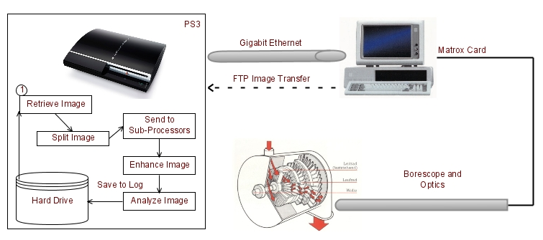
Figure 8 - Overall System
This process consists of four sub-systems: Simulation Hardware, Communication Systems, Image Processing and PS3 Unit. The following section breaks each sub-system down in detail.

Simulation Hardware

The simulation hardware will consist of a propeller blade connected to a DC motor that will emulate the turbine. The motor will be controlled by an H-Bridge (electronic components that will be constructed on a prototyping board) and will interface with an Arduino microprocessor. The H-Bridge will be connected to a 12VDC power supply to supply the motor with enough current to run up to 1000 rpm. The Arduino microprocessor will be connected to a laptop that will control the motor’s speed. A rotary encoder will be used to record the motor speed and send it back to the laptop for closed loop feedback. The Arduino will also be connected to LEDs to help control the lighting on the blades, so the camera can capture optimal images. In addition, an Apple iSight Camera will be used to capture images of the blade. The laptop will be running software that will determine the speed of the motor and trigger the camera to take photos when the blade is in position.
The Arduino Microprocessor was selected for this project because of its low cost, high level of versatility and ease of use. The Arduino USB Microprocessor is widely used by hobbyists and artists to help them quickly create their systems. The programming environment for this microprocessor is very basic: It can be programmed quickly and easily. Although the environment is easy to understand and quick to learn, it is very extensive and can do some of the more complex functions you would expect on higher end microprocessor. Overall, the cost of the Arduino is $35.00, making it economically friendly as well as easy to work with.
The electronic circuitry consists of an H-bridge unit that will be made from scratch from basic electronic components. The H-bridge will be used to drive the motor because the Arduino cannot provide enough current to get the motor to 1000 rpms. The L293 H-bridge will be used to make the H-bridge (which will be driven by a 12 V DC power supply). The turbine system will be emulated by a medium sized DC motor, which will be connected to a rotary encoder so that its position can be tracked.
The laptop that is going to be used can be either an Apple laptop or a PC. For our system an Apple Laptop will be used to develop the software. The software for the microprocessor will be developed using the Arduino SDK. Then, a visual software development environment called “Processing” will be used to create a graphical display program for the system. The Arduino microprocessor will send two signals back to the laptop: the first signal will refer to the position of the rotary encoder to get the speed for closed loop control and the second signal will tell the laptop to send a signal to “Processing” to trigger a camera to take a photo.
The camera that we are going to use is an Apple iSight Camera. This camera was selected because it is very easy to take high-speed images and it is one of the few cameras that can be interfaced with “Processing”. In addition, the camera uses a firewire connect to the laptop so the data will be sent very quickly and will allow for multiple images to be taken quickly.
LED lighting was selected for this application because it is the easiest way to generate computer-controlled lighting. The LEDs will be interfaced with the Arduino so that the light can be controlled by the laptop via serial signal to the Arduino.

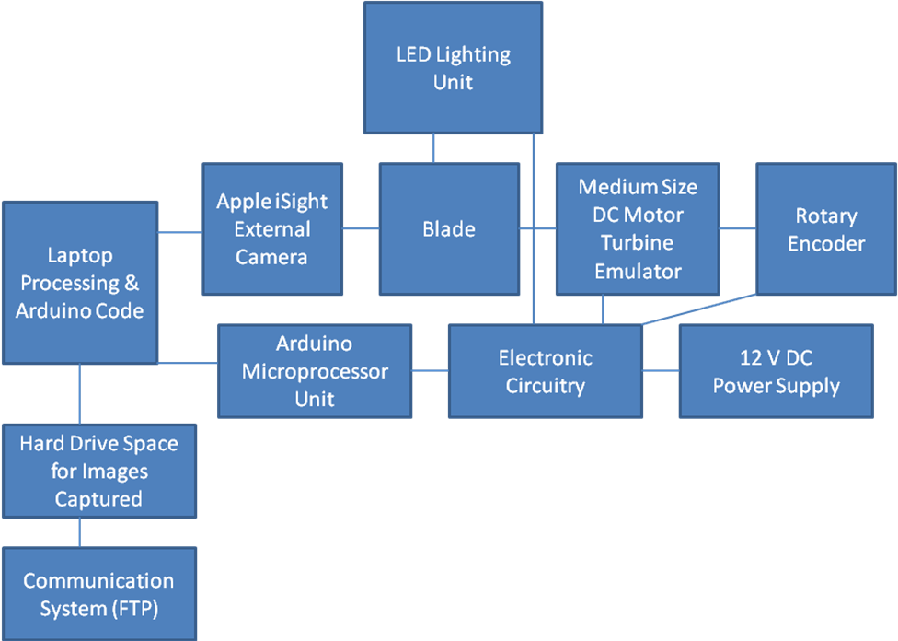
Figure 9 - Preliminary Design for Simulation Hardware

Figure 9 shows the interaction between the different components for the simulation hardware. The 12 V DC power supply will supply the electronic circuitry with enough current to run the motor. The motor will emulate a turbine by being connected to a propeller blade. The motor’s speed will be monitored by a rotary encoder that will send signals through an Arduino microprocessor to the computer. The H-bridge will also be connected to the Arduino so that the computer can set the motor’s speed. The computer will interpret these signals and tell a camera when to take pictures of the blades. LED lights will also be connected to the Arduino so that the computer’s user can select the proper lighting. After the camera takes the pictures, they will be saved into a folder in the hard drive. Finally, the communication system can use FTP to access that folder and grab images from there.

The team currently has Internet resources with detailed plans on how to make an H-bridge, connect it to a motor and interface it with an Arduino:

http://itp.nyu.edu/physcomp/Labs/DCMotorControl

The team has developed a plan on how to read a rotary encoder to track the blade’s position:

http://www.arduino.cc/playground/Main/RotaryEncoders

The team also has plans on how to control LEDs with an Arduino:

http://www.arduino.cc/en/Tutorial/Dimmer

Finally, the team has a way to use the “Processing” IDE to take a picture from a camera:

http://www.processing.org/learning/libraries/gettingstartedcapture.html

In addition to building the simulation hardware, the team will write code to link all of these components together. After the components are linked together, the team will test the simulation system to make sure the images are high quality. At this point, the simulation hardware system will be ready to interface with the rest of the project. The team is currently in the implementation phase.
Currently, the team has the Arduino Programming SDK, Processing SDK and a laptop. The system will require a purchase of an Arduino, iSight Camera, L293 H-bridge, several resistors, 25-50 LEDs, 12 V DC power supply, rotary encoder, motor, propeller blade, protoboard, materials to mount the camera into the system, a holder for the motor and other components.

Communication System

The communication system is responsible for transferring digital images from the image source to the PS3 reliably and accurately. The medium chosen is the wired 802.3 Gigabit Ethernet port on the PS3. This allows the system to communicate through a highly reliable and high bandwidth connection to nearly any other device.

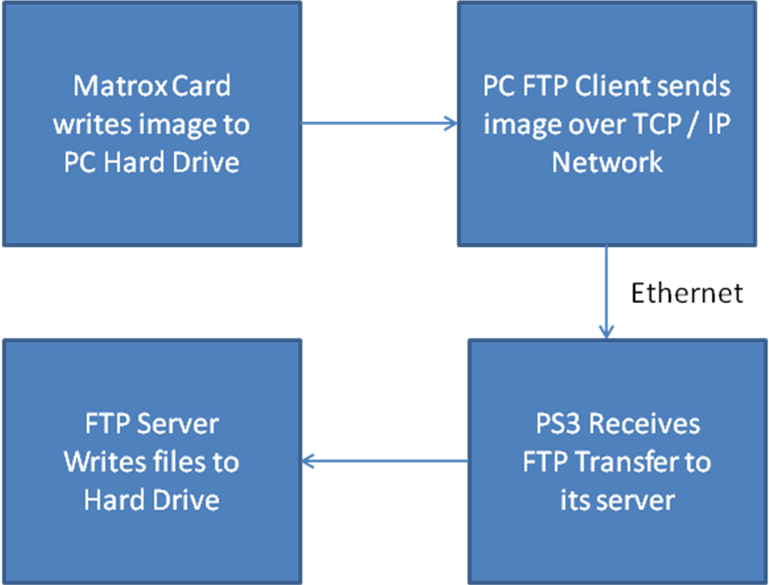
Figure 10 - Flow Chart of Communication System

The communication system is dependent upon the image source, whether it is a connected USB, PCI card or network camera. Figure 10 depicts the system currently in use by the other GE team. In this case, they have installed a Matrox card to their PC and the camera connects directly through the card. Previous sections have used USB cameras and network cameras. Considering that the camera may change at any given time, we need a communication solution that is as all-encompassing.
The File Transfer Protocol (FTP) was chosen because of its widespread use, small footprint and reliability. In the case of a network camera, research has shown that nearly all of the network cameras use FTP for their transfer. For other solutions that utilize a PC, there are many solutions that automatically send files through FTP.
Since FTP is a client-server protocol, it requires both sides to be configured for transfer. Due to the fact that the PC with the images is under the responsibility of another team, an established FTP server or client has not been established. The PS3 would operate as a server, allowing users to login in order to upload files, whereby the other processes of the PS3 could access them.

Image Processing

In order for the system to produce accurate and efficient results, the image algorithm design needs to be:
- Clear and concise, for easy future development
- Accurate enough to meet project objectives
- Able to be implemented onto different platforms

The algorithm will first be implemented using MATLAB. Then, it will be converted into C code using the Deploy Tool that is readily available within the environment. The system will be receiving TIFF images from the hardware team. These images will then be decoded into a matrix format via MATLAB. The matrix data is then passed into the algorithm and processed accordingly to identify the levels of erosion present on the turbine blade. During the final phase, the system will output a log file indicating the level and rate of erosions on the particular blade.
Currently, the image processing system is in the design phase and will take approximately 3 weeks to deploy into the testing phase. The team has analyzed the overall system through data analysis and research, coming up with a myriad of different techniques to further investigate the levels of erosion.
The analytical techniques covered are:
- Rotation
- Transformation
- Contrast
- Fourier Transform
- Average Distance
- Edge Detection
- Standard Deviation
- Comparison

As for now, the system will be tested for its tolerance based on the following performance measures:
- Time it takes to process the data and output
- Accuracy to produce reliable output

Since the relevant tools are currently available with the necessary licenses, no purchases need to be made for the time being.

PS3Unit
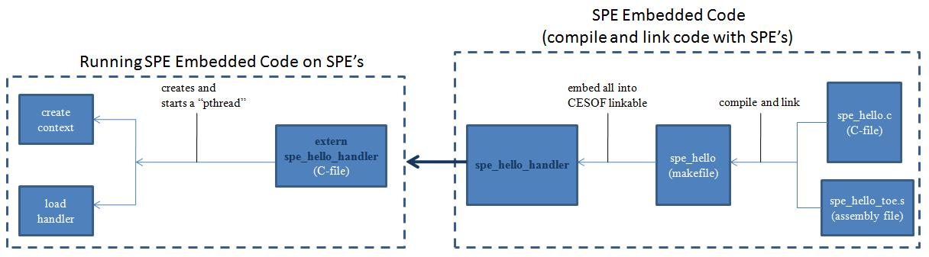
Figure 11 - LibSPE Flow Chart

LibSPE does not modify the hardware resources. It is user-level code that requests SPE resources from the operating system. The term “context” is used in LibSPE, and this refers to the SPE resource that the operating system is managing. You can run one or more SPE simultaneous execution threads by creating that many threads in the PPE code and then run the SPE program in each thread [Bartlett 2007].
The first step is to create Embedded SPE Code, which uses CBE Embedded SPE Object Format (CESOF). The CESOF requires the SPE program to declare a special kind of variable to hold the address value of any variables that get passed in. For example, if a variable called “foo” is getting passed in from the PPE to the SPE, this variable must have the _EAR_ prefix. These variables can be declared “unsigned long long” for 64-bit address values.
The assembly file may be generated automatically by the SPE compiler. If not, an assembly is necessary to manually define an EAR entry and its associated EAR symbol in the special .toe section. These two files are necessary to compile and link, using the SPE compiler, into an SPE executable file using the makefile. It is then necessary to embed everything into a CESOF linkable. The handle name (spe_hello_handle in Figure 3), is important because it acts as the “connection” from the PPE to the SPE embedded code [Chow 2006].
The C-file that is created to run the SPE embedded code must contain an extern with the same name as the embedded SPE program handler. From here, a “pthread” (an API for creating and manipulating threads) gets created, as well as an SPE context (consists of local store, contents of all 128 registers, state of the channels and state of DMA commands in progress; essentially used to save and restore the context of an SPE at any point in time). Finally, the SPE code is loaded into the context and the SPE code is run until completion.

9. Project Plan
Summary of Methodology

Based on the client requirements presented, the team will investigate and define objectives to identify the problems associated with the current environment that are to be resolved. In order to reach the team objectives, the first step is to analyze the current available systems. The project’s development and implementation environments were carefully selected based on the technically feasible options available. In the physical design of the project, multi-layered preparation will include learning the rules of the implementation environment, reviewing the precise requirements for logical to physical mapping and planning the approach. Once completing the specification of tasks, tests to determine the strength of the data process design will be carried out repeatedly to encourage extended development. The objective of this phase is to determine the physical data and process design using the components and features of the chosen physical environment and incorporating installation standards.
As part of the research involved, proper documentation will be developed by each team member. For example, for proper code justification the team will be using Doxygen, which is a documentation system for C/C++. Therefore, all research and design processes are to be posted in the corresponding section of the ECSE Design forums. (https://forum.ecse.rpi.edu/) Major research areas will include PlayStation 3 (PS3), image processing, IBM’s Cell SDK, Fedora Core 5, Yellow Dog Linux OS, and Optimization Algorithms for related topics.

Design Strategy

The overall layout of the system design must be pieced out into several components before making any changes or additions to the hardware. However, the team should be aware of certain constraints that will be based on the design and the designs practicability. Knowing that the project will be heavily based on the software design, the design will be utilizing the Unified Modeling Language (UML) as much as possible to accommodate better understanding and referencing. This pertains to specific program functions and algorithms. The entire system will be documented using proper graphical notations to create an abstract model of the system in order to be able to forecast problems before delving into the development phase. It is also important to note that most detailed diagrams and planning will go into the algorithm designs because of its enormous complexity. As a result, there must be detailed design documentation on the process and reasons behind the choices that were made.
Reports are divided into sections, with each group or team member working on a specific section. The team will also meet to review parts that members have written, and to help with sections that require input from the entire team. After the individual sections are written, one or two team members will be designated to act as editors who will put the different sections together and edit the report for consistency and grammar.
At each meeting, detailed minutes are recorded and posted in the forums for future references.

Design Iteration Configuration and Change Management

Previous team’s set up on the PS3 included the Fedora 5 Linux; however, our team decided that the best option is to install Yellow Dog Linux, given its extensive online support that includes debugging methods of Yellow Dog Linux on the PS3. After carefully examining the hardware, the team discovered that the simulation hardware that was used for image capturing weren’t properly intact and labeled. Therefore the next design iteration will incorporate the usage of Labview, a Data Acquisition Card and basic circuitry to control the simulation hardware.
The source code for the project will be managed through version control. Other updates will be made through the forum, keeping people up to date on status of various sections.

Project Team & Skill Sets

- Paul Ireifej
  - Computer and Systems Engineer & Computer Science
  - Hardware/Software Communication
  - Database Design
  - GUI Programming
- Justin Law
  - Computer and Systems Engineer
  - Control Systems concentration
  - Image Processing and documentation writing
  - C/C+
- Carlos Lazo
  - Computer and Systems Engineer & Computer Science
  - Automatic control and robotics concentration
  - C/C++, Java, Python, Scheme, VB/VBA, SQL
  - Experience using Linux
- Nick Matthews
  - Computer Systems Engineer & Computer Science
  - Networking Concentration
  - Cisco Certified Networking Associate (CCNA)
  - Cisco Certified Networking Professional (CCNP)
  - C/C++
- Shahab Rastegar
  - Electrical Engineer
  - Matlab Image Processing
  - C/C++
- Thomas Smith
  - Computer and Systems Engineer
- Syed Reza Ali
  - Mechanical and Electrical Engineer
  - Adobe (Photoshop, Illustrator, Premiere, Flash, Dreamweaver)
  - Arduino Programming and Processing Programming
  - Circuit Design (digital, analog) & Embedded Control
  - Autodesk Maya, Solidworks, Cinema 4D
- Mahmutcan Tarzi
  - Computer and Systems Engineer
  - Automatic Control and Robotics concentration

Work Breakdown Structure

Preliminary assignments based on individual interests:
Networking & Operating Systems Team
- Paul Ireifej
- Mahmutcan Tarzi
Image Processing Team
- Justin Law
- Carlos Lazo
- Shahab Rastegar
Interface & API Team
- Nicholas Matthews
- Syed Reza Ali
- Thomas Smith

Schedule

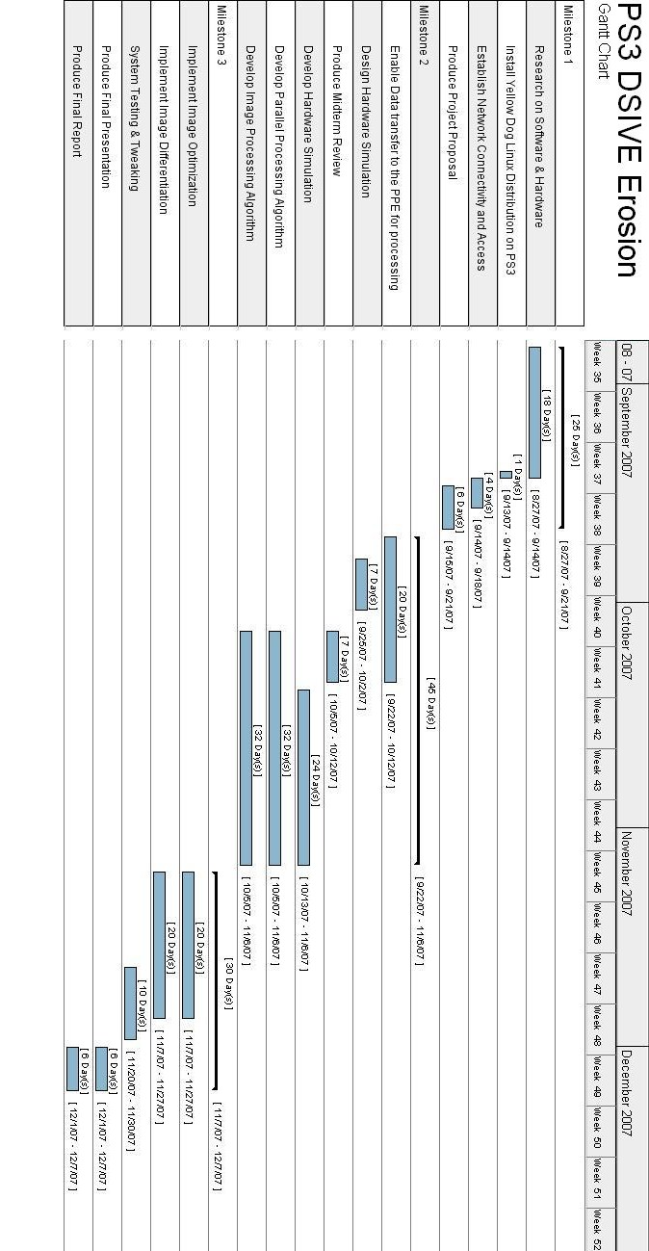
Figure 12 - Gantt Chart

Preliminary Budget
The budget will provide the team with both essential and backup tools to efficiently develop the tasks set out. The team’s budget is listed below in Table 4,
Table 4 - Preliminary Budget
Item | Quantity | Estimated Cost (US$)
Apple iSight Camera | 1 | 250.00
Arduino | 1 | 35.00
Electronic Circuitry (wire, breadboard) |  | 40.00
Gear Motor | 1 | 8.00
LED | 50 | 50.00
PlayStation 3 | 1 | 500.00
Power Supply (12V 1000mA 22W) | 1 | 25.00

- The team’s preliminary budget adds to a total figure of US$ 908.00
- The extra Playstation3 will function as a backup in case the current Playstation3 console stops functioning correctly
- The Arduino microprocessor will be incorporated into the hardware simulation as a motor speed controller

Deliverables
- A Playstation3 running under a Linux distribution
  - Type of Distribution: Yellow Dog Linux
  - Distribution Version: 5.0.2
- A system using the PlayStation 3 that will accept an image of a predetermined size and quality from a remote PC and efficiently output a data log with erosion analysis
- Produce a mid-term review and documentation on the process of the team’s design for future development
- Final report and presentation of the final outputs

Project Risks
Risks denote the concept of a potential negative impact to an asset or in this scenario, a threat towards the end goal of the project. Given the nature of the project, risks types of different aspects will arise. These risks are divided into major and minor risks. Major risks will significantly impact the project, while the minor risks are at a minimal but still pose a threat towards meeting the goals of the project. Table 5 summarizes the types of risks involved and mitigation plans to counteract each scenario respectively.

Table 5 - Project risks
ID | Risk Description | Probability  0 - 10 (high) | Severity  0 - 10 (high) | Priority  (PxS) | Risk Response Plan
1.0 | Major risks
1.1 | The total objectives requested may be beyond what the team can deliver in time available | 10 | 5 | 50 | Assign levels of importance to the use cases. Clarify project scope after 4 weeks
1.2 | Client may accept delivery of the system although it does not really meet their goals | 5 | 10 | 50 | Clients are asked to declare acceptance criteria as each objective is planned
1.3 | Client goals may conflict | 5 | 10 | 50 | Keep an explicit list of client goals. The project manager will report progress to each declared goal
1.4 | Requirements are only partly known at project start; Client may not allocate sufficient resources to exploring requirements | 5 | 10 | 50 | Requirements will be detailed first for the top priority goals
1.5 | Communication problems between development team; They are divided into subgroups and have not worked together previously | 5 | 10 | 50 | Give constructive and positive feedback; Identify strengths of each individual and help strengthen weak areas
2.0 | Minor risks
2.1 | Development team might not be able to estimate the work time, preventing project manager from deciding priorities effectively | 5 | 5 | 25 | The development team will gain experience in estimating the work and deliver first estimates after the first 4 weeks. Team will compare estimated work to actual work
2.2 | Team members may leave the project before it is completed | 2 | 8 | 16 | Each member of the team should keep up to date with every section of the project. Project manager will discuss areas of interest and delegate tasks appropriately
2.3 | The system as delivered may have low accuracy | 3 | 7 | 21 | Detail objectives and deliverables are set early in the project to help define client expectations
2.4 | The system delivered may have poor usability | 3 | 9 | 27 | The system will have a simple GUI, well documented procedures and references of the project
2.5 | After requirements have been documented and agreed, changes to requirements or new changes that are introduced will affect the system and time efficiency | 3 | 10 | 30 | Changes are only made when the cost is worthwhile. Indicator: compare cost of change to new development; Contingency: request client/project manager review of requirements
2.4 | Team may not cooperate in common standards and processes | 1 | 10 | 10 | Have brief meetings to discuss conformance to change or modify the work standard as appropriate
2.5 | The system delivered might be difficult to maintain | 1 | 5 | 5 | Extensive documentation and reference will be made available to future teams and clients through ECSE design forum for further development
2.6 | Improper use of new technologies.  e.g. insufficient background support for OS distribution when implemented in project | 3 | 9 | 27 | Extensive research on usability and support of each technology that will be implemented sequentially narrowing down choices to be implemented
2.7 | System hardware failure | 5 | 2 | 10 | System will be tested using the PS3 and PC. Backup hardware will be available/purchased to act as replacements

References
Adelman, J., Cardoso, R., Hidlay, T., Jarvis, R., Puthenveettil, S., & Sroka, G. (2007) Final Design Report for Erosion Project.

Adelman, J., Cardoso, R., Hidlay, T., Jarvis, R., Puthenveettil, S., & Sroka, G. (2007) Mid Term Design Report for Erosion Project.

AfterDawn.com, Forums, Internet. (2007) Available: http://forums.afterdawn.com/, September 2007.

Amarasingehe, S., & Rabbah, R., Multicore Programming Primer: Lectures, Internet. (2007) Available: http://cag.csail.mit.edu/ps3/lectures.shtml, September 2007.

Arduino, What is Arduino?, Internet. (2007) Available: http://www.arduino.cc/, September 2007.

Bara, T., Carcich, B., Gibb J., Huang R., Lang A., Malarik, D., & Sylvestre B. (2007). Final Report for Medical Imaging with PS3 and Cell Processor, 2 – 69.

Bartlett, Jonathan, Changes in LibSPE: How LibSPE2 affects Cell Broadband Engine programming, Internet. (2007) Available: http://www.ibm.com/developerworks/linux/library/pa-libspe2/index.html?ca=drs-m, September 2007.

Cabral, R., Chu, J., Hall, I., Mullin, J., Nakagawa, P., Quinn, R., & Smith, F. ( 2007). Final Report for PS3 DSIVE: Distributed Shared Immersive Visualization Environment, 2 – 74.

Cabral, R., Chu, J., Hall, I., Mullin, J., Nakagawa, P., Quinn, R., & Smith, F. ( 2007). Mid Term Design Report for PS3 DSIVE: Distributed Shared Immersive Visualization Environment.

Carcich, Benjamin. (2007). Background Information Regarding Cell SDK Programming.

CDW Corporation, AXIS 206 Network Camera, Internet. (2007) Available: http://www.cdw.com/shop/products/specs.aspx?EDC=697029&cm_sp=Product-_-Specs-_-Main+Tab, September 2007.

Chow Chunghen, Alex, Programming the Cell Broadband Engine, Internet. (2006) Available: http://gamasutra.com/features/20060721/chow_01.shtml, October 2007.
Files Library, Free Download VNC Manager, Internet. (2005) Available: http://www.files-library.com/files/VNC-Manager.html, September 2007.

FreeBSD: The Power to Serve, FreeBSD / ppc Project, Internet. (2007) Available: http://www.freebsd.org/platforms/ppc.html, September 2007.

Future Gamez, PlayStation 3 System Specs, Internet. (2006) Available: http://www.futuregamez.net/hardware/ps3hard/system/system.html, October 2007.

Gentoo Linux, About Gentoo, Internet. (2006) Available: http://www.gentoo.org/main/en/about.xml, September 2007.

Helpero, UBUNTU vs. SUSE vs. FEDORA, Internet. (2006) Available: http://news.helpero.com/article/UBUNTU-vs-SUSE-vs-FEDORA_20.html, September 2007.

Hertzfeld, Andy, “Programmers at Work”, Internet. (2002) Available: http://pages.prodigy.net/wheel3/wip/os_wars_rage_on.txt, September 2007.

IBM Cell Broadband Engine Software Development Kit, Internet. (2005) Available: http://www.alphaworks.ibm.com/tech/cellsw, September 2007.

Lane, Tom, JPEG Image Compression FAQ, Internet. (1999) Available: http://www.faqs.org/faqs/jpeg-faq/part1/, September 2007.

LinuxDevices.com, SDK aims Playstation 3 clusters at HPC apps, Internet. (2007) Available: http://www.linuxdevices.com/news/NS4555177850.html, September 2007.

Mullin, James (2007). Individual Deliverables #2. Erosion - Spring 2007 MidtermReport draft.doc

Nakagawa, Patrick. (2007). PS3 DSIVE. Mid Term Design Report for PS3 DSIVE, Spring07 Version 0.07

Oregon State University, Open Source Lab, Internet. (2007) Available: http://gentoo.osuosl.org/experimental/ppc64/livecd/, September 2007.

Paul, Ryan. Yellow Dog Linux on the PlayStation 3, Internet. (2006) Available: http://arstechnica.com/articles/columns/linux/linux-20061018.ars/2, September 2007.

PS3 Linux FAQ Thread, QJ.NET Forums, Internet. (2006) Available: http://forums.qj.net/f-ps3-linux-283/t-ps3-linux-faq-thread-78750.html, September 2007.

Psubuntu.com, Why PSUbuntu?, Internet. (2007) Available: http://psubuntu.com/about, September 2007.

Rousseau, Stacy, Steam Turbines: A look into how a steam turbine functions, Internet. (2001). Available: http://www.nd.edu/~techrev/Archive/Fall2001/a5.html, September 2007.
Silverman, Dwight, Ask TechBlog: Ubuntu or Vista?, Internet. (2007) Available: http://blogs.chron.com/techblog/archives/2007/01/ask_techblog_ubuntu_or_vista.html, September 2007.

Valdes, Robert, How PlayStation 3 Works, Internet. (2007) Available: http://electronics.howstuffworks.com/playstation-three5.htm, September 2007.

Yellow Dog, Linux Community Board, Internet. (2007) Available: http://www.yellowdog-board.com/, September 2007.

Wikipedia, PlayStation 3 hardware, Internet. (2007) Available: http://en.wikipedia.org/wiki/PlayStation_3_hardware, October 2007.

Wikipedia, Cell (microprocessor), Internet. (2007) Available: http://en.wikipedia.org/wiki/Cell_microprocessor, September 2007.
Wikipedia, Steam turbine, Internet. (2007) Available: http://en.wikipedia.org/wiki/Steam_turbine, September 2007.

Appendix A: Test Plan
Testing is to be conducted in order to ensure that all team goals have been met and also to validate that our design meets customer requirements. To do so, the team must create a prototype. The prototype shall be then used to simulate real world conditions. These simulations will show vulnerabilities and errors that must be addressed.
Two testing environments shall be set for testing; one will be the PS3 with Yellow Dog installed and the other will be emulation software for the PS3 that will be run on student laptops. Below please find a list of areas which will require testing and analysis:
Install Yellow Dog Linux on PS3 –
After the installation of Yellow Dog Linux, there must be tests conducted to gage the stability and robustness of the system. These tests may include stress testing and verification that services required for the project are working (e.g. SDK).
Establish Network Connectivity and Access –
Verify that the PS3 can be remotely accessed and files are transferred over the network with no corruption. SSH, VNC and SAMBA must all be tested. Testing must also be done to ensure that pictures can successfully be transferred from the PC connected to the camera to the PS3.
Transferring Image to the PPE for processing –
The bridge between the FTP stream and the Power Processing Element (PPE) must be tested.
Develop Parallel Processing Usage - the team must conduct testing In order to gage the effectiveness of the Parallel Processing. Same image shall be processed with and without Parallel Processing and the time difference will be measured.
Image Optimization and Differentiation – this section of the project will be the most code intensive. The algorithms implemented must one by one be tested for both accuracy and efficiency.
Output Results to PS3- the final step in our testing process will be to test the output. The output will be in form of a log; this log must be tested to ensure that it is consistent with the results of analysis algorithm. A simple GUI will also be used to ease the use of the software. Command shall be issued using this GUI. The Functionality of this GUI must be tested.

Appendix B: LibSPE2 Sample Code
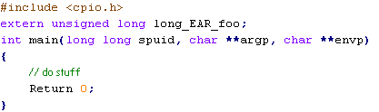
Figure 13 - spe_hello.c

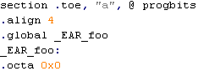
Figure 14 - spe_hello_toe.s

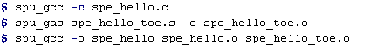
Figure 15 - Uses the SPE compiler to compile and link into an SPE executable file

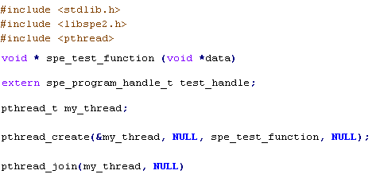
Figure 16 - Create and run "pthread "
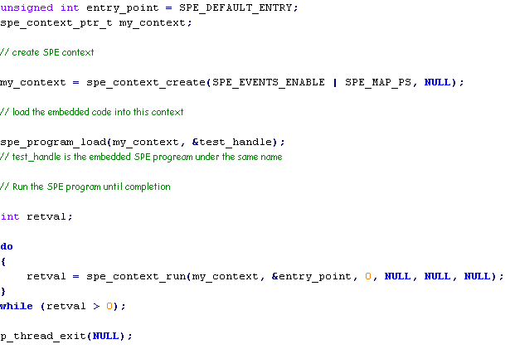
Figure 17 - SPE context

